Apache Tomcat Home Page(http://localhost:8080/) not Loading Even after the server is up and Running(HTTP 404 - Page Not Found Error).
- You have Apache Tomcat Server Installed in your laptop and configured it using Eclipse.

- Upon starting the Apache Tomcat Server from Eclipse, when we visit http://localhost:8080/ - Apache Tomcat Home Page should get displayed.

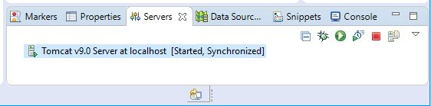

- If you are facing (HTTP 404 - Page Not Found Error) :
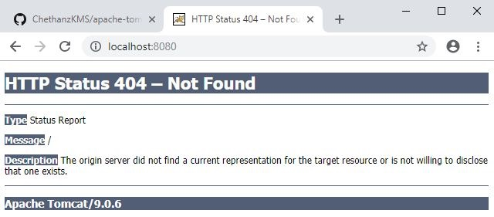
- then the below hack should get you pass the hurdle.

- Goto Apache Tomcat Installation Directory in your laptop:
Something Like: C:\Program Files\Apache Software Foundation\Tomcat 9.0
- Go Inside “webapps” folder and you should be able to find folder of name “ROOT”.
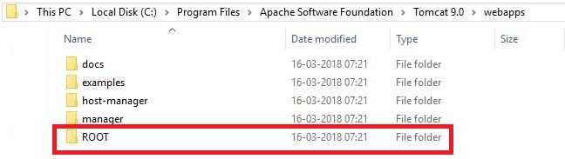
- Copy the “ROOT” folder.
- Goto your eclipse workspace where the project is created and stored.
- In my case it is : E:\Java Programs
- Go inside “.metadata” folder and search for “wtpwebapps”.
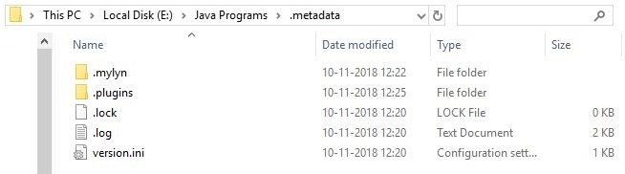
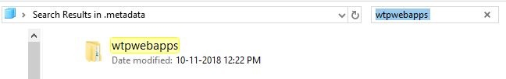
- Go Inside “wtpwebapps” folder and you should be able to see another “ROOT” folder.
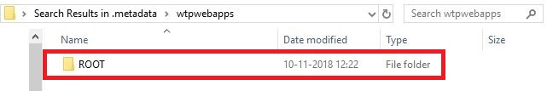
- Merge the copied “ROOT” folder from Apache Tomcat Installation Directory “webapps” folder with “ROOT” folder in wtpwebapps in eclipse workspace.
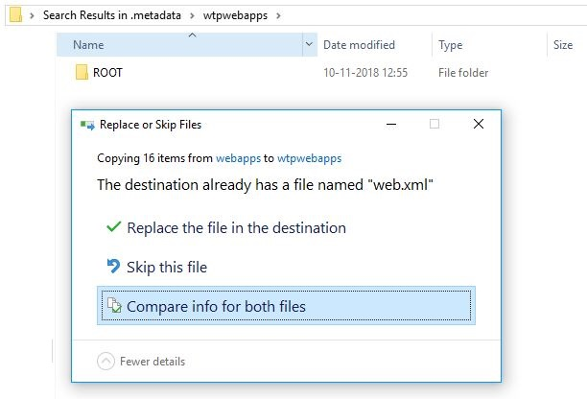
- Restart the server and visit - (http://localhost:8080/)
- You should be able to see Apache Tomcat Home page.

